Exercise 6
  - Machine Learning I

6A-1.

First, rearrange through Bayes theorem:
$$p\left(t|X\right)=\frac{p\left(t|w,X\right)p\left(w|X\right)}{p\left(w|t,X\right)}$$
Decompose:

$$\log{p\left(t|X\right)}=\log{p\left(t|w,X\right)}+\log{p\left(w|X\right)}-\log{p\left(w|t,X\right)}$$We already determined the densities for the likelihood, posterior and prior in the previous exercises. No need to recompute everything again. Because above has to be valid for any $w$, we pick $w=μ_{N}$ for convenience.
Let us first convert only the exponent
$$\begin{matrix}\log{p\left(t|X\right)} & ∝-\frac{1}{2}{\left(t-Φw\right)}^{T}τ_{ϵ}I\left(t-Φw\right)-\frac{1}{2}w^{T}τ_{0}Iw & \\ & +\frac{1}{2}{\left(w-τ_{e}Σ_{N}Φ^{T}t\right)}^{T}\left(τ_{0}I+τ_{e}Φ^{T}Φ\right)\left(w-τ_{e}Σ_{N}Φ^{T}t\right) & \\ & =-\frac{1}{2}{\left(t-Φμ_{N}\right)}^{T}τ_{ϵ}I\left(t-Φμ_{N}\right)-\frac{1}{2}{μ_{N}}^{T}τ_{0}Iμ_{N} & set w=μ_{N}\end{matrix}$$Now let us add the normalization constants:
$$\log{p\left(t|X\right)}=-\frac{1}{2}{\left(t-Φμ_{N}\right)}^{T}τ_{ϵ}I\left(t-Φμ_{N}\right)-\frac{1}{2}{μ_{N}}^{T}τ_{0}Iμ_{N}+\frac{1}{\left|r_{0}\right|}$$
$$\begin{matrix}\log{p\left(t|X\right)} & =-\frac{1}{2}{\left(t-Φμ_{N}\right)}^{T}τ_{ϵ}I\left(t-Φμ_{N}\right)-\frac{1}{2}{μ_{N}}^{T}τ_{0}Iμ_{N} \\ & +\frac{d}{2}\log{r_{0}}+\frac{n}{2}\log{r_{ϵ}}\frac{n}{2}\log{2π}+\log\left|Σ_{n}\right|\end{matrix}$$
TODO: Nochmal Terme überprüfen…

6A-2.

Let $w_{MAX}$ be the (unregularized) maximum likelihood parameters. The lasso path illustrates the current selection of weights $w_{i}$ given weight regularization $\left\|w_{current}\right\|=\frac{t}{{\left\|w_{MAX}\right\|}_{1}}, t∈\left[0,{\left\|w_{MAX}\right\|}_{1}\right]$. For a very thorough and detailed explanation, please refer to page 69 of “Elements of statistical learning”.
You can find the online version here:
https://web.stanford.edu/~hastie/ElemStatLearn//printings/ESLII_print10.pdf
This means that for low values on the $x$ axis, the model is heavily regularized. Moving along the $x$ axis then relaxes the regularization constraint until you get to the unregularized maximum likelihood solution $\left\|w_{MAX}\right\|$.
In order to study what happens, we are using now 3 classes. Using a design matrix, we can model each degree $x^{i}$ of the regression polynomial $y\left(x\right)=\sum_{i=0}^{d}{w_{i}x^{i}}$ as a separate dimension for the lasso path.
Let us have
$$f\left(x\right)=4-2x+2x^{2}-x^{3}$$
Given enough samples, the maximum likelihood solution should set our regressor weights as such:
$$w_{0}=4, w_{1}=-2, w_{2}=2, w_{3}=-1$$
This can be seen, if we look at the right end of our lasso path:
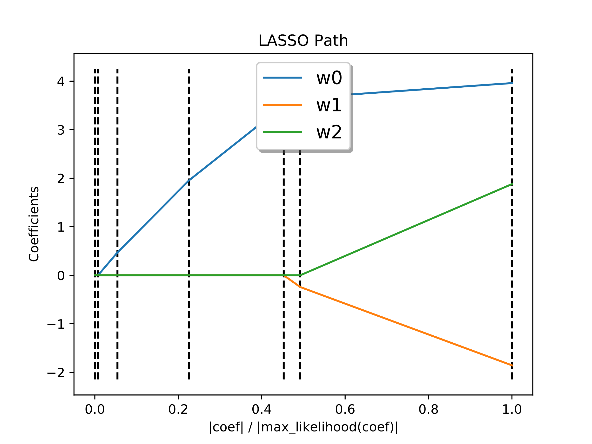
The less we regularize our weights (we move towards x=1) the more we obtain the maximum likelihood
solution for our weights. Model was created with n=3000 samples and sample interval $I=\left(0,2\right)$.
Now something should be noted: In the above image, weight $w_{0}$ was picked up first, then $w_{1}$ and lastly $w_{2}$. This means, in this case, relaxing the lasso translates to gradually picking up model complexity.
Now we are ready for eight classes. Our polynomial is
$$g\left(x\right)=2-3x+4x^{2}-5x^{3}+4x^{4}-4x^{5}+6x^{6}-5x^{7}$$
The order of weight pick up is very much dependent on the sample interval $I$. Shown are two pictures of the same function $g\left(x\right)$, one time with a sample interval of $I=(0,25)$ and one time with $I=\left(-1,1\right)$: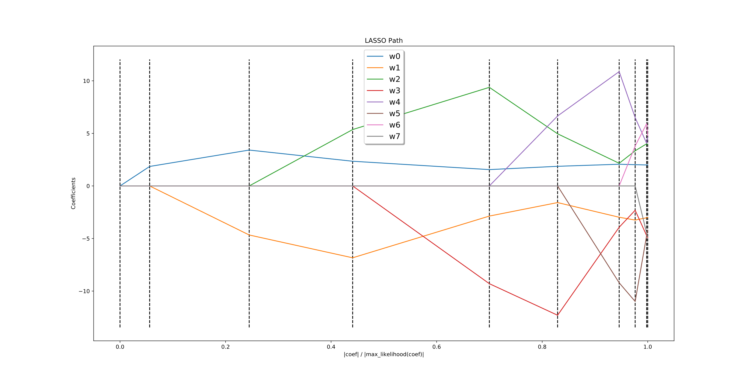
Figure 1 n=70000, I=(-1,1). The weights are picked up in ascending order of degree.
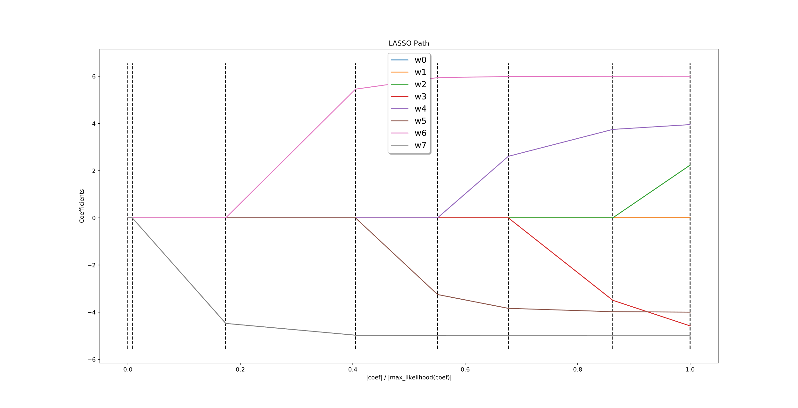
Figure 2 n=70000, I=(0,25). The weights are mostly picked up in descending order.
Think about why this happens (Tip: With polynomial basis functions, we have $x^{i}≤x^{j}, i<j, x∈\left[-1,1\right]$.
What does this mean for our regularized error?).
If we put the length of our interval between the ascending (I=(-1,1)) and descending (I=(0,25)) cases, then the following more chaotic weight pick up happens: 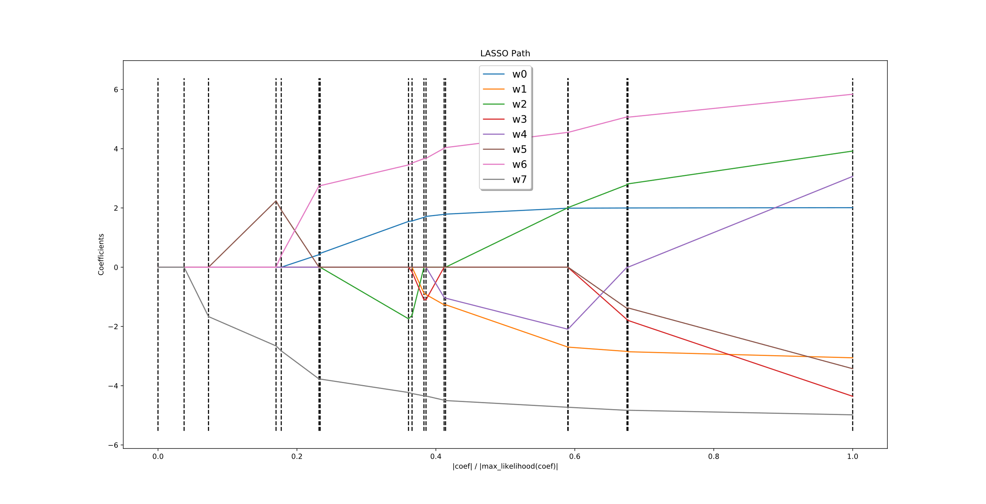
Figure 3 n=70000, I=(0,2) Chaotic pick up of weights

6A-3.

  - The noise $ϵ$ is symmetric around $t$. So by the same way we derived $t\sim N\left(t;w^{T}x,ϵ\right)$ when the noise was normal, we can now say
$$t\sim Stud_t\left(t;ν,w^{T}x,σ_{ϵ}^{2}\right)$$
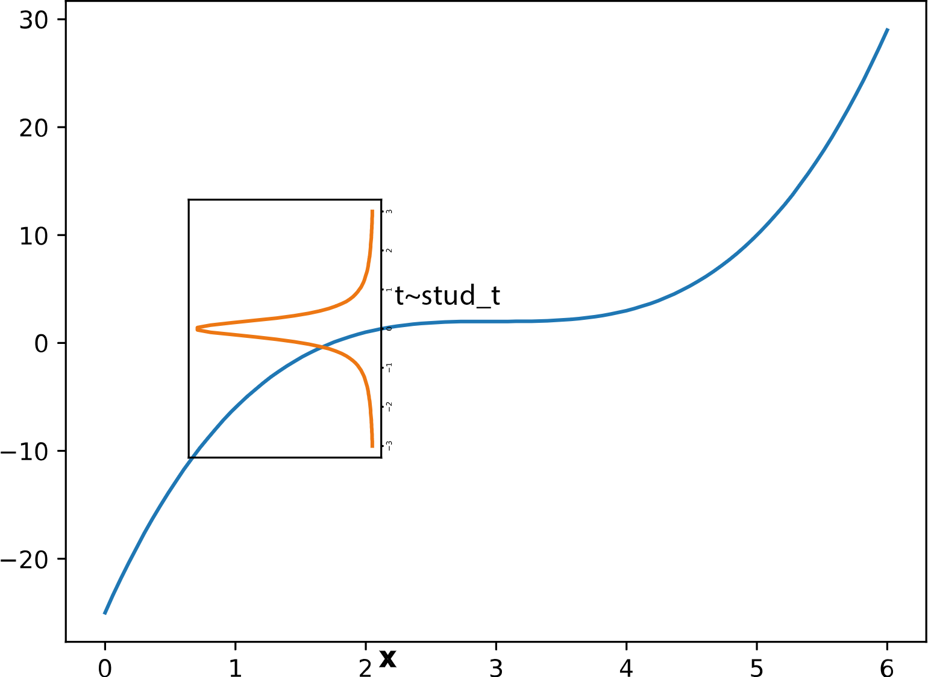
Figure 4 Because the noise is symmetrically distributed around $t$ and the
hidden function f(x) is non-random (p(t|x)=1 for one value of t),$t$ is identically distributed
to its noise with adjusted mean.
This leads to the log likelihood:
$$\begin{matrix}\log{p\left(t|x,ν,σ_{ϵ}\right)} & =\log{\prod_{i=1}^{n}{Stud_t\left(t_{i};ν,w^{T}x_{i},σ_{ϵ}^{2}\right)}} \\ & =n\left[\log{Γ\left(\frac{ν+1}{2}\right)}-\log\left(\sqrt{νπσ_{ϵ}^{2}}Γ\left(\frac{ν}{2}\right)\right)\right] \\ & -\frac{\left(ν+1\right)}{2}\sum_{i=1}^{n}{\left(1+\frac{1}{ν}\frac{\left(t_{i}-w^{T}x_{i}\right)}{σ_{ϵ}^{2}} \right)}\end{matrix}$$
Let us set $d=\left(t_{1}-w^{T}x_{1}\right)$. We now plot the error of one datapoint in comparison to a log normal pdf. The following picture was attained with the parameters $σ$
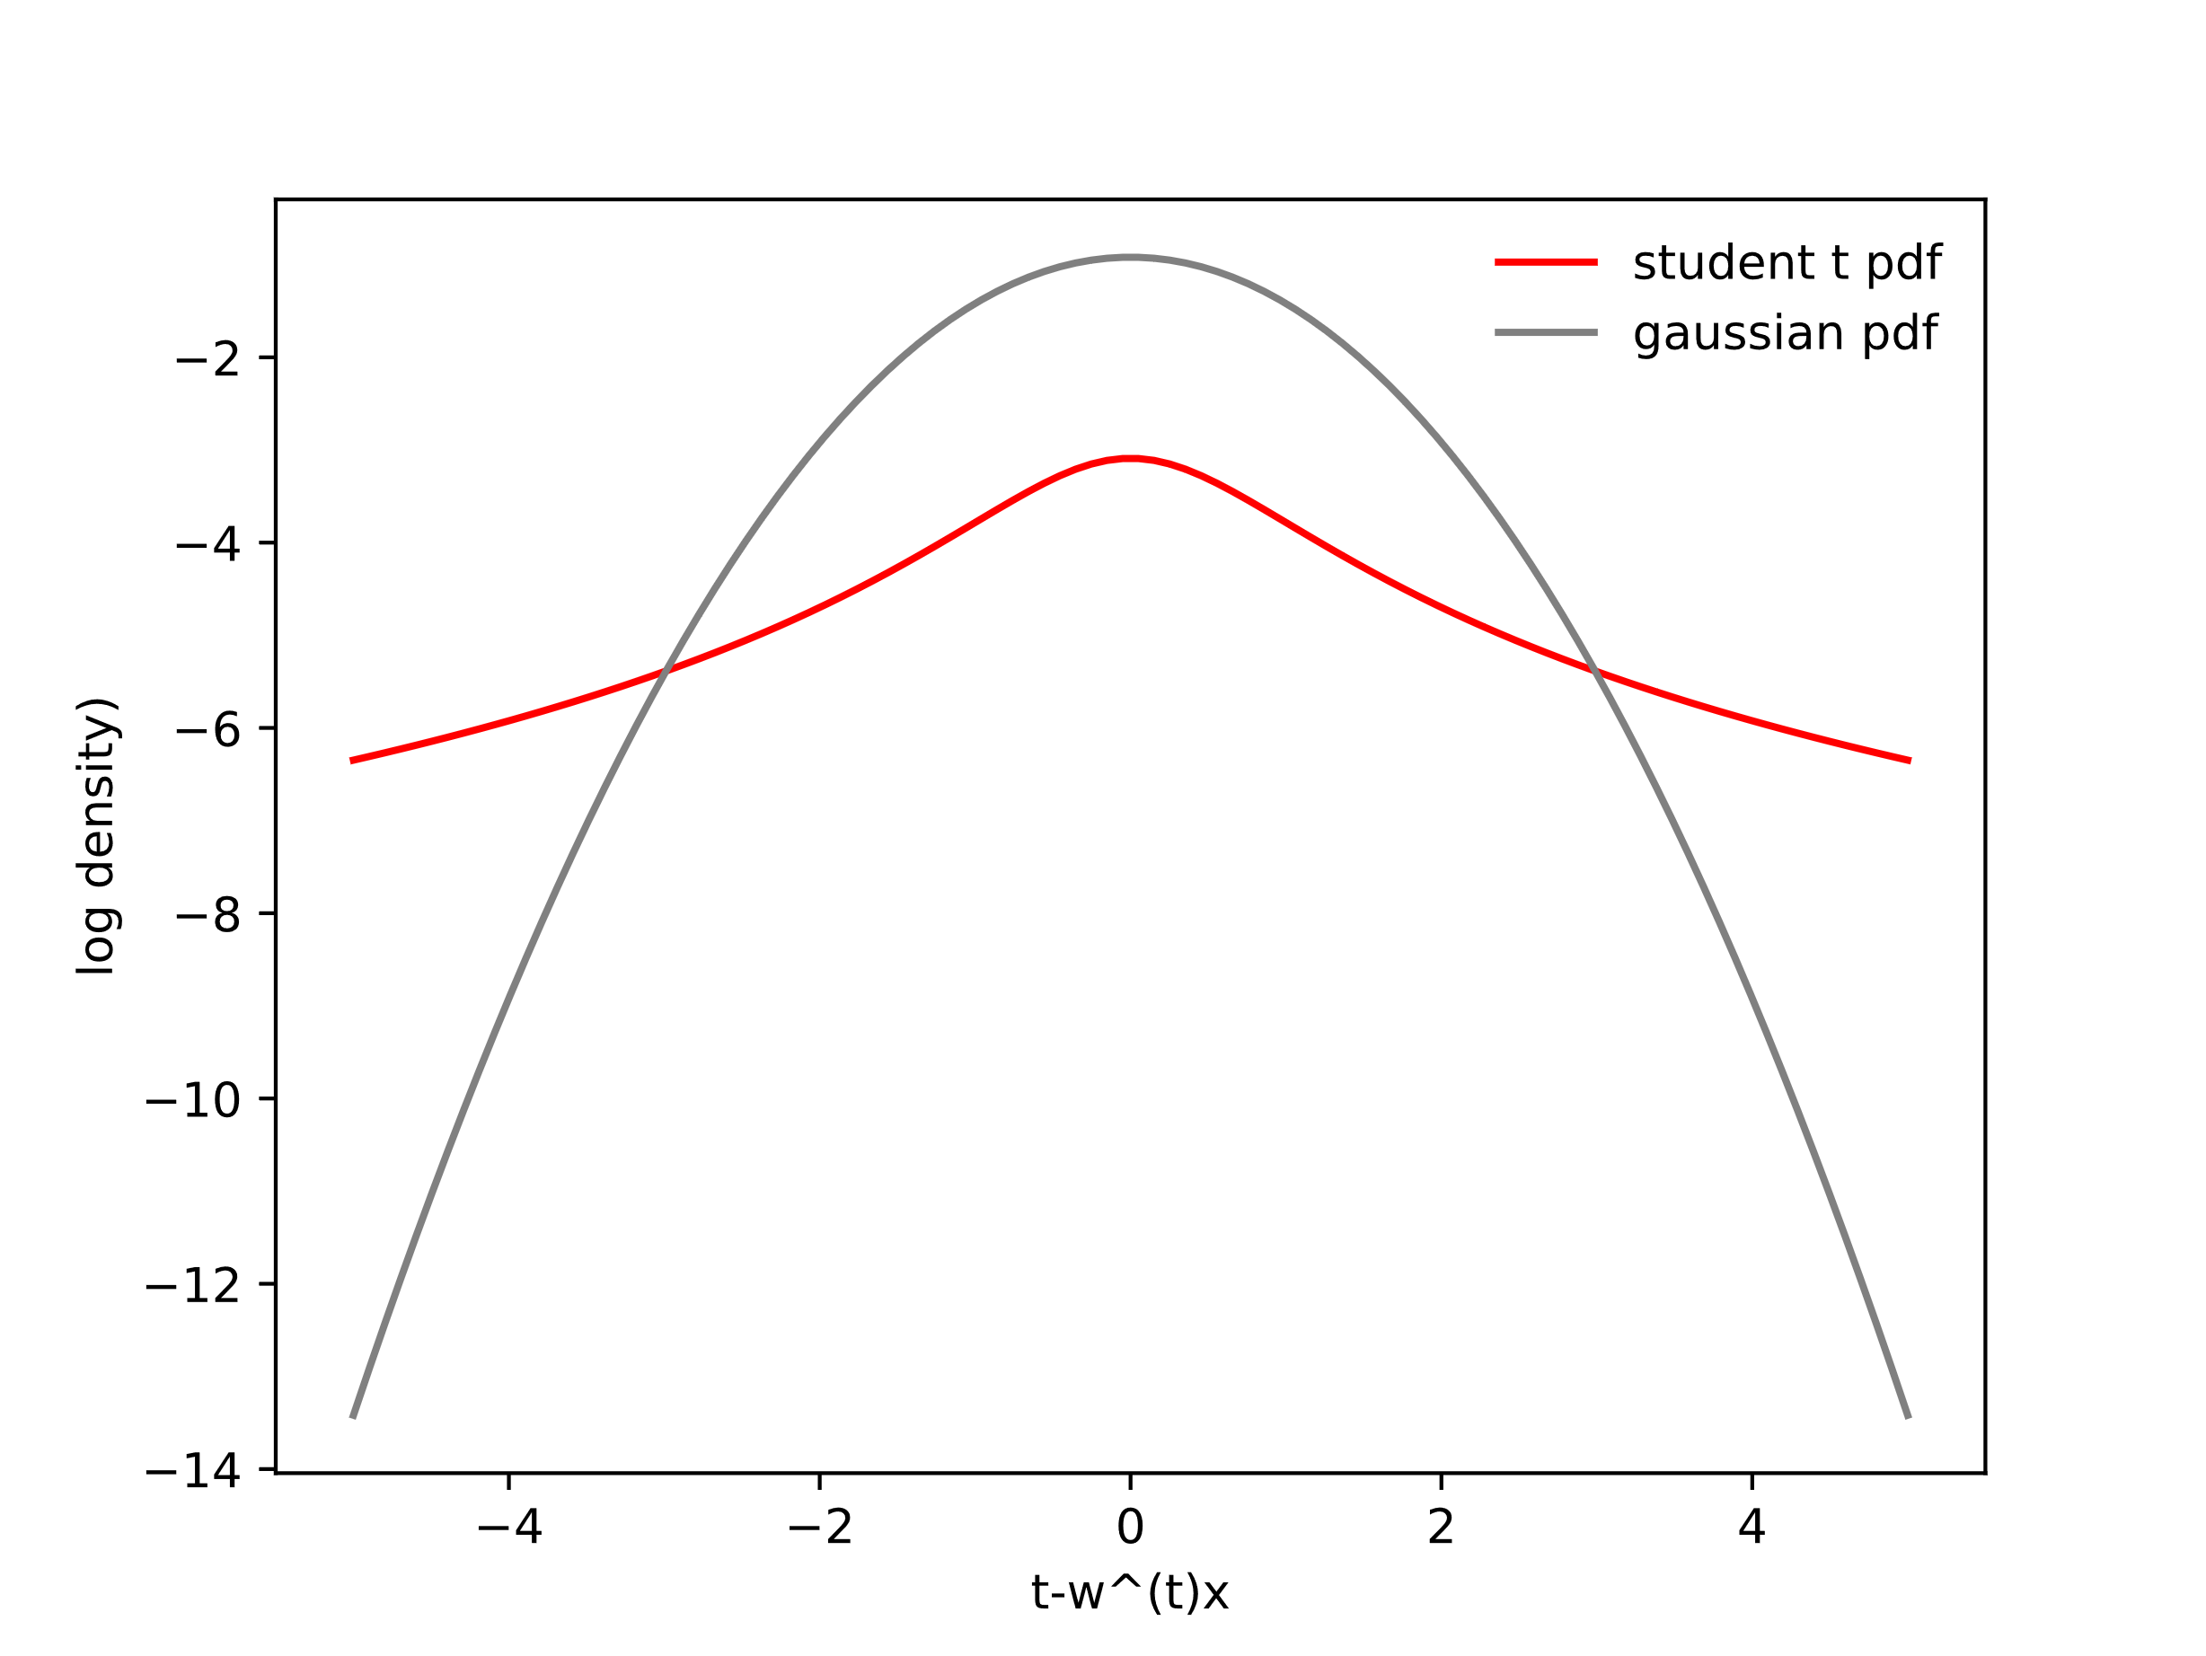
Figure 5 Comparison of the test error between a log normal pdf and
a student t pdf. Image was attained with the parameters $σ_{ϵ}=1, ν=1$.
For small errors $w^{T}x≈t$, the student t distribution appears to be less forgiving, as less density is concentrated around small errors ($\log{Stud_t\left(t_{1};1,d,1\right)}<\log{N\left(t_{1};d,1\right)}$). Larger errors $\left|w^{T}x\right|≫\left|t\right|$ are less penalized however, as $\log{N\left(t_{1};d,1\right)}<\log{Stud_t\left(t_{1};1,d,1\right)}$.
Generally speaking, this means if we try to maximize our weights $w$ with respect to $e\sim N\left(0,σ^{2}\right)$, then our fit is trying to mitigate large errors while being mostly indifferent to smaller ones.
If we maximize $w$ with respect to $t\sim Stud_t\left(t;ν,w^{T}x,σ_{ϵ}^{2}\right)$, we get a more balanced fit, we small deviations are considered.

